[Organisation] · PHASE B
Process Modelling Convention
BPMN 2.0, with three worked examples from the claims and distribution streams
Field | Detail
Version | 0.1 — Draft
Date | May 2027
Owner | Business Domain Architect
Approver | Architecture Board
Standard | OMG BPMN 2.0.2. [Organisation] uses the Descriptive conformance sub-class, extended with three elements from Analytic: manual task, business rule task and error end event.
Classification | Internal

1. Where this sits
The Tailored Architecture Framework removed process flow diagrams at enterprise level from Phase B. This document does not reverse that decision; it sets the convention for the process models the operating units do produce.

Question | Position
What the framework says | Process flow diagrams at enterprise level were removed from Phase B. Value streams cover the enterprise view; process detail belongs to the operating units.
What this document is | The convention those units follow, and three examples showing it applied. It is a standard, not a catalogue.
What the repository holds | This convention, these three examples, and any process model produced as evidence for a gate. Not every process [Organisation] runs.
When a process is modelled at all | When it is being changed, when it crosses a unit boundary, or when a regulator has asked how it works. Modelling a stable process nobody is changing produces a document that ages badly.

A standard, not a catalogue
The repository holds this convention and these three examples. It does not hold every process [Organisation] runs, and it should not. A process model is produced when the process is being changed, when it crosses a unit boundary, or when a regulator has asked how it works.

2. Which elements [Organisation] uses
BPMN 2.0 is large. [Organisation] constrains it to the Descriptive conformance sub-class plus three Analytic elements, because a model the operating unit cannot read is a model the operating unit will not maintain.

Element | Sub-class | Position | Why
Pool | Descriptive | Used | One pool per participant. A second pool means a party [Organisation] does not control.
Lane | Descriptive | Used | Divides responsibility inside a participant. Lanes are roles or units, never systems and never individuals.
Start event, plain and message | Descriptive | Used | Every process starts with an event. A process that starts with a task has not been thought through.
End event, plain | Descriptive | Used | Every path ends. An unterminated path is the commonest modelling error.
End event, error | Analytic | Used | Marks a path that terminates because something failed, not because it finished.
User task | Descriptive | Used | A person doing work in a system.
Service task | Descriptive | Used | Automated, no human. If it takes days, it is not a service task.
Manual task | Analytic | Used | A person working outside any system. These are where cycle time hides, so they are marked.
Business rule task | Analytic | Used | A decision taken by rules rather than judgement. Marks candidates for externalising.
Send and receive task | Descriptive | Used | Crossing a pool boundary.
Exclusive gateway | Descriptive | Used | One path taken. Must carry a question and its answers on the flows.
Parallel gateway | Descriptive | Used | All paths taken. Both branches must converge.
Sequence flow | Descriptive | Used | Solid. Never crosses a pool boundary.
Message flow | Descriptive | Used | Dashed. Only crosses a pool boundary.
Data object | Descriptive | Used | What a task needs or produces. Used sparingly, and only where the data is the point.
Text annotation | Descriptive | Used | Where a task carries a fact the shape cannot. Most useful for cycle time and cause.
Inclusive gateway | Analytic | Not used | Ambiguous to read and rarely necessary. Model it as parallel with conditions instead.
Event sub-process | Analytic | Not used | Adds a second reading order to a diagram most readers already find dense.
Complex gateway | Common | Not used | If a decision needs a complex gateway, it needs a business rule task and a decision model.
Compensation and transaction | Common | Not used | [Organisation] has no process where compensation semantics would be honoured by the systems beneath.
Choreography and conversation | Common | Not used | A separate diagram type. Message flows on a collaboration diagram carry what [Organisation] needs.

3. Modelling rules
Rule | Why
Name a task verb-then-object | "Establish quantum", not "Quantum establishment" or "Assessment". A noun is a stage, not a task.
Name a gateway as a question | "Within mandate?" with the answers on the outgoing flows. A gateway with unlabelled flows is unreadable six months later.
One participant per pool, one role per lane | A lane named after a system is a category error. Systems are how work is done, not who does it.
Mark manual tasks | They are where cycle time accumulates and where automation pays. [Organisation]'s three examples each have one, and each is the longest task in its process.
Annotate with cause, not opinion | "18 days" is a fact. "Too slow" is not. Where the cause is architectural, say so plainly.
Model as-is before to-be, and keep both | A to-be model with no as-is beside it cannot be argued with, and gets approved for that reason.
The model is owned by the unit, not by architecture | Architecture sets the convention and reviews conformance. The operating unit owns the content and keeps it current.

The model is owned by the unit, not by architecture
Architecture sets this convention and reviews conformance at a gate. The operating unit owns the content and keeps it current. A model architecture maintains on the unit's behalf is a model nobody believes.

4. BPR-07 / BPR-08 — Notify and validate a funeral claim
Value stream | What the model shows
VST-02 Settle a Claim, stages 1 to 3 | Two participants, three lanes, a message flow to an external party, and an exclusive gateway with a workaround branch.
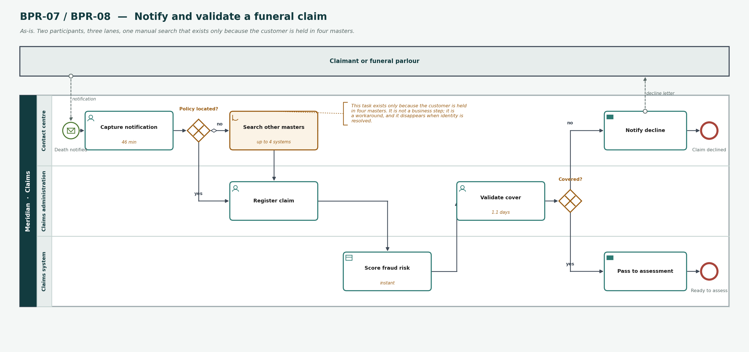
Figure 1 — BPR-07 / BPR-08 Notify and validate a funeral claim. As-is.
Why this one was chosen
The 'search other masters' task is not a business step. It exists because the customer is held in four systems, and it disappears when identity is resolved. Modelling it makes the cost of the data problem visible in a process the business recognises.

5. BPR-09 — Assess a claim
Value stream | What the model shows
VST-02 Settle a Claim, stage 4 | Three lanes, two exclusive gateways, an error end event, and two data objects, one of which does not exist.
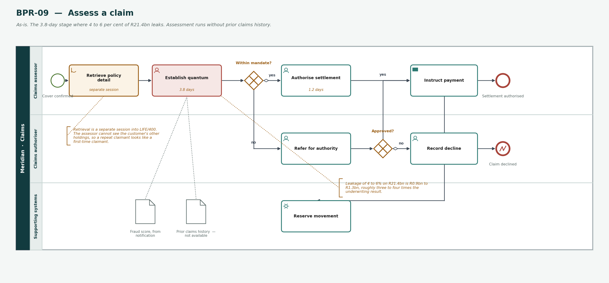
Figure 2 — BPR-09 Assess a claim. As-is.
Why this one was chosen
The most valuable element on the diagram is a data object marked 'not available'. Prior claims history across lines is what an assessor needs and cannot get, and it is the direct cause of leakage worth R0.9bn to R1.3bn.

6. BPR-19 — Accredit an intermediary
Value stream | What the model shows
VST-06 Onboard an Intermediary, stages 2 to 4 | A collapsed pool for the broker, a service task next to a manual one, and both gateway branches terminated.
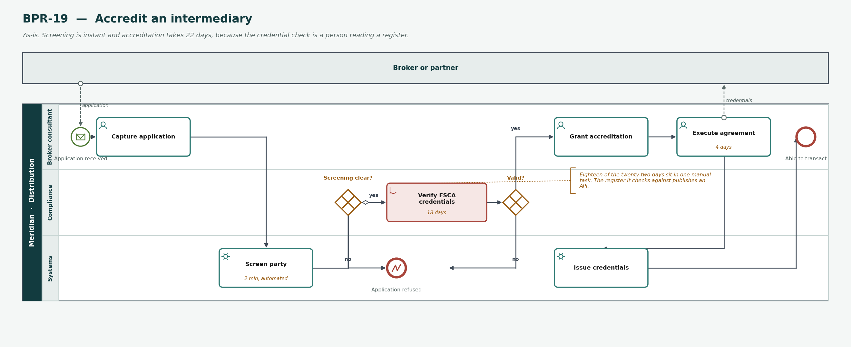
Figure 3 — BPR-19 Accredit an intermediary. As-is.
Why this one was chosen
Screening is a service task taking two minutes. Credential verification is a manual task taking eighteen days, against a register that publishes an API. The two sit side by side, which is the argument.

7. What the three models show together
Every example contains one manual task, and it is the longest task in its process
Search other masters, retrieve policy detail, verify FSCA credentials.
That is not a coincidence of selection. Manual tasks are where cycle time accumulates, and marking them is the single most useful thing the notation does for [Organisation].
Two of the three contain a task that should not exist
Searching four customer masters, and retrieving policy detail in a separate session.
Neither is a business step. Both are workarounds for the same architectural problem, and modelling them puts that problem in front of the people who feel it rather than the people who caused it.
The most important element in the second example is a data object that is empty
Prior claims history, marked not available.
Notation is usually used to describe what happens. Here it is used to show what cannot happen, which is harder to argue with than a slide saying the same thing.
Nothing in these three needs a construct beyond Descriptive plus three
Manual task, business rule task and error end event. Everything else used is Descriptive.
The full BPMN element set is large and mostly unnecessary. Constraining it is what makes the models readable by the operating units that own them.

Related documents
- Value Stream Definition — the 38 stages these processes sit inside
- Business Capability Map — the capabilities the tasks realise
- Organization Map — the units and roles the lanes name
- Tailored Architecture Framework — Phase B, and the removal this convention respects

